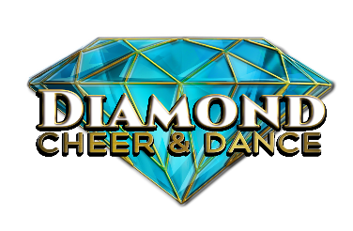
DIAMOND CHEER & DANCE & THE FINALE
DANCE SCORE SHEET BREAKDOWN
Most = 50% of team Majority = 75% of team All = 100% of team
Scores are based on your team’s performance at an event compared to other teams in your division. There could be a variance in scores from event to event due to different judging panels.

Dance Ranges
1.0-4.0 Team did not meet minimum standards in that specific dance category
4.0-6.0 Novice- Less than most of the team (<50%) showed excellence or perfection
6.0-8.0 Intermediate-Majority of team (75%) showed excellence or perfection
8.0-10.10 Advanced- All of the team (100%) showed excellence or perfection

When being judged in any particular dance category on the score sheet, the judges will place you in 1 of 4 ranges. For simplicity reasons and to help coaches improve their score throughout the season, Diamond Cheer and Dance has split the ranges into an easy to understand range.

