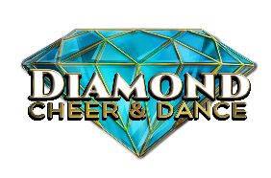
DIAMOND CHEER & DANCE
INDIVIDUALS

DIVISION: _______________________ LEVEL: _____________

NAME(s): _____________________________________________

JUDGE NUMBER: ____________

CATEGORY | POINTS  50 | SCORE | COMMENTS
CHOREOGRAPHY/CREATIVITY | 5
MOTIONS/DANCE | 5
STANDING  TUMBLING | 10
RUNNING TUMBLING | 10
JUMPS | 10
OVERALL EXECUTION & IMPRESSION | 10
TOTAL

ROUTINE TIME: _______________ INITIALS:____________

