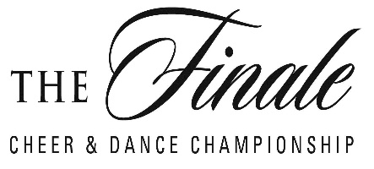

MAJORETTE DANCE CREATIVE, POM & FIELD SHOW
DIVISION: _______________________________________________
TEAM NAME: _____________________________________________
JUDGE NUMBER: ____________

CATEGORY | POINTS  100 | SCORE | COMMENTS
CHOREOGRAPHY  Dance arrangements, concept | 20
THEME & MUSIC- Musicality, beat technique, synchronization, timing, moves related to the music | 20
ORIGINALITY –  Incorporating unique and original/creative moves | 20
PERFORMACE –  Entertainment value, crowd appeal, staging formations, level changes, synchronization, execution showmanship, and variety of skills | 40
TOTAL

ROUTINE TIME: _______________ INITIALS:_______________

