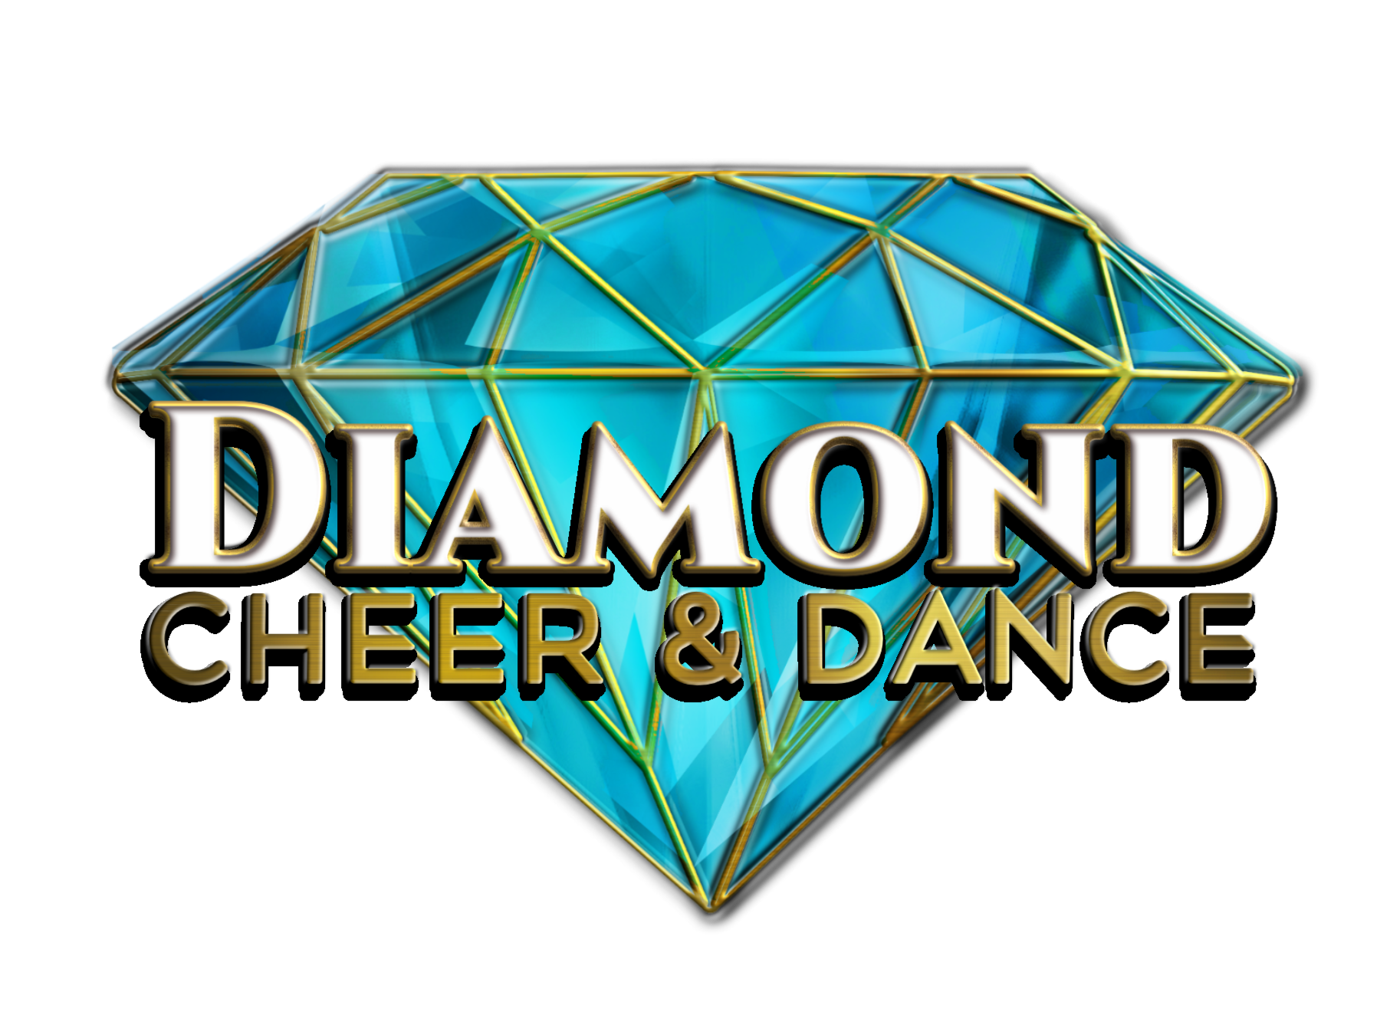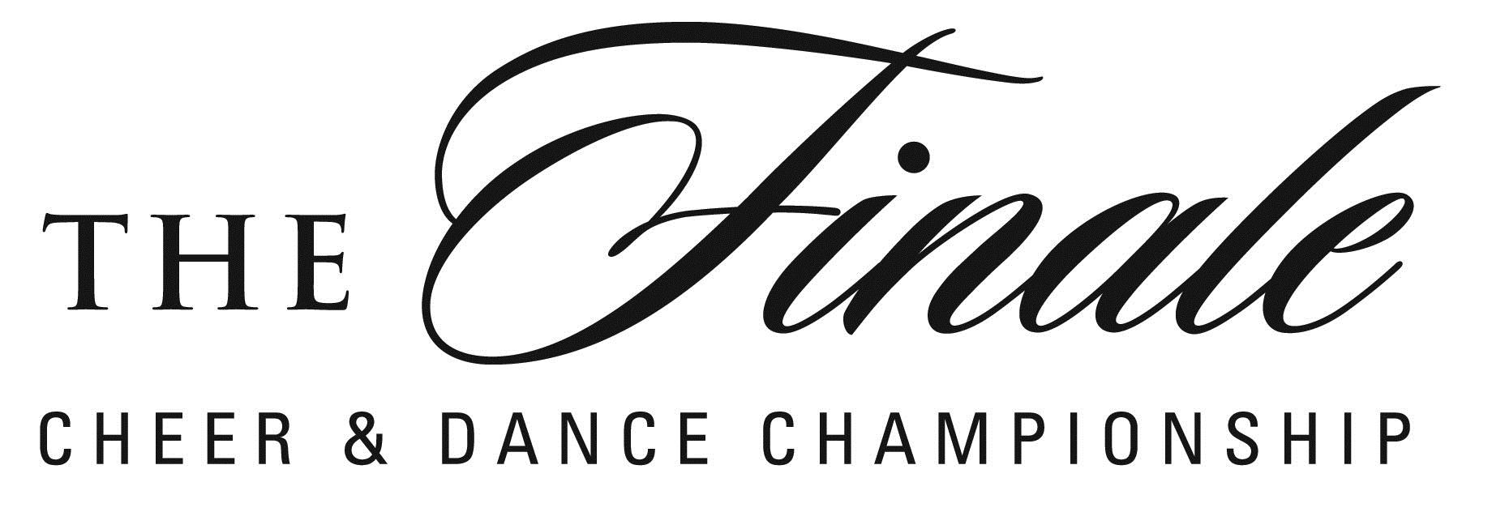
TWIRLING SCORE SHEET

TEAM NAME/DIVISION: ___________________________________________________________________
Scoring Grid
Weak  0-10 | Low fair  11 | Fair  12 | High fair  13 | Low Avg  14 | Avg  15 | Good  16 | V/ Good 17 | Exc  18 | Sup.  19

Possible Points | Category | Score | Comment
20  ROUTINE DESIGN | Musical Interpretation, Floor coverage, Continuity, Staging, Change of pace, Special effects, Development of theme, Creativity
20  TWIRL | Variety, Difficulty, Smoothness & Gracefulness, General handling, Combinations of Batons/Body, Combinations of other selected twirling apparatus, transitions, Twirls appropriate for show twirl.
20  BODY  MOVEMENTS | Variety & Difficulty of Movements, Turns, Lunges, Kicks, Leaps, Footwork, Arms, Combinations of Body/Baton, Rhythm, Timing, Phasing
20  TECHNIQUE QUALITY OF PERFORMANCE | Execution-Perfection/Precision, Body Lines-Upper Body/Lower Body, Posture/Leg Lines/Footwork, Quality of Reproducted Music
20  SHOWMANSHIP  PRESENTATION | Projection, Entertainment Value, Confidence, Poise, Appearance, Grooming, Costuming, Audience Appeal
 | TOTAL
PENALTIES
 | 0.5 | 1.0 | 1.5 | 2.0 | 2.5 | 3.0 |  | 3.5 | 4.0 | 4.5 |  | 5.0 | 5.5 | 6.0
Drops
Fall
 | 0.1 | 0.2 | 0.3 | 0.4 | 0.5 | 0.6 |  | 0.7 | 0.8 | 0.9 |  | 1.0 | 1.1 | 1.2
Break
Off Pattrn
Unison
Undertime (.1 per sec) |  |  | Overtime (.1 per sec) |  |  |  | Improper Salute (.5) |  |  |  | Failure to Salute (1.0)

Judge#____________________ Routine Time #______________________ Penalty ____________________

