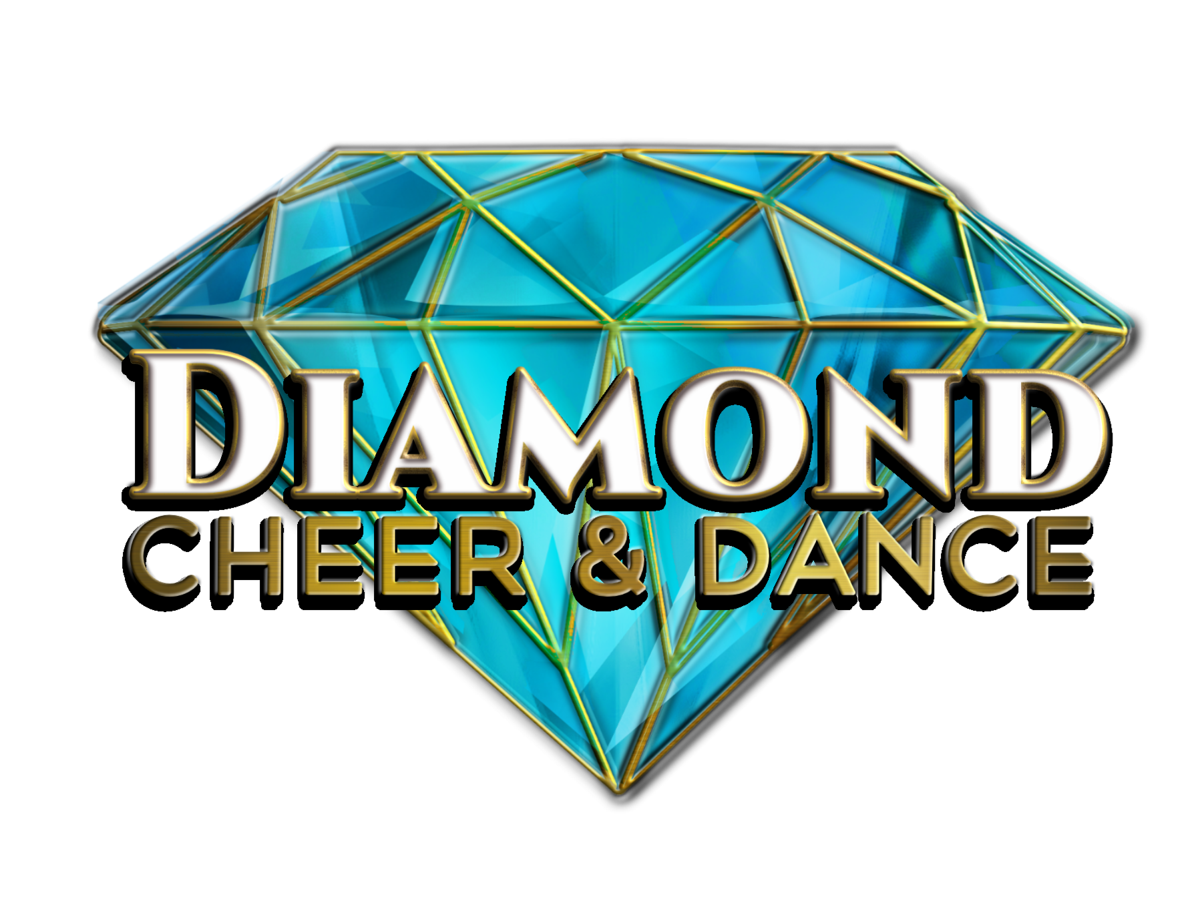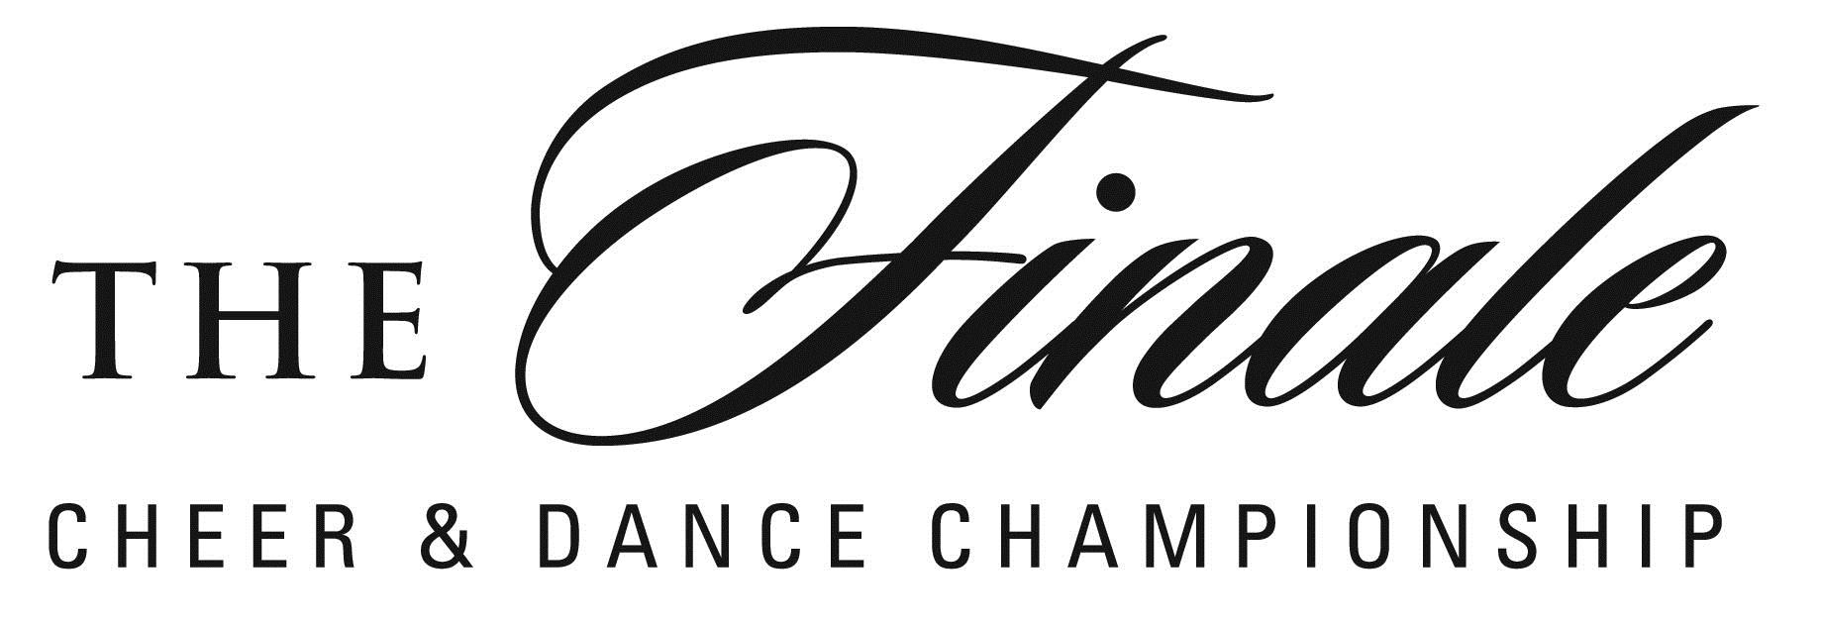

DANCE PENALTY SHEET

STUDIO, ALL-STAR, RECREATIONAL, SCHOOLS,
SOLOS, DUOS, TRIOS & INDIVIDUALS

EVENT:_____________________ TEAM NAME:____________________

DIVISION:______________________

TIME LIMITS:

All-Star, Recreational & School=Teams: 2 minutes 30 seconds
All-Star, Recreational & School=Individuals: 1 minute 30 seconds

Studio solos, duos & trios=3 minutes maximum
Studio small, medium & large groups=4 minutes maximum
Studio production=8 minutes maximum

Ballet & Point: No gymnastics/acrobatics/tumbling .5 x ____ = ____

Tap, Jazz, Lyrical Jazz & clogging-No more than 3
gymnastics/acrobatics/tumbling .5 x ____ = ____

Over time in routine 5.0 x ____ = ____
TOTAL= ____

Comments:

Routine Time:__________ Judge’s Initials:__________

